**People First Adult Program**

**Kermode Friendship Society**



**Final Report [1]**

**To**

**Homelessness Partnering Strategy,**

**Project #: 1441631**

**Innovative Solutions to Homelessness**

**Employment and Social Development Canada**

**Table of Contents**

Acronyms…………………………………………………………………….. Page 3

Executive Summary…………………………………………………………. Page 4

Introduction…………………………………………………………,…………Page 5

Methodology…………………………………………………….……………. Page 5

Expected Deliverables articulated in the proposal……………….…………………………………………………….…. Page 6

Key Achievements……………………………………………………………. Page 9

Outstanding Client Success Stories……………………………………..…. Page 10

Shared Knowledge and Increased Engagement…………………………...Page 10

Managing Challenges………………………………………………………...Page 11

Lessons learned……………………………………………………………...Page 12

Recommendations……………………………………………………………Page 12

Conclusion …………………………………………………………………… Page 12

Appendices

Appendix A – Cohort 1 and 2 comparatives……………………………... Page 15

Appendix B – Write-ups of Clients mentioned in Final Report…………. Page 16

Acknowledgement of Funding……………………………………………….. Page 21

**Acronyms**

ESDC – Employment & Social Development Canada

ILD – Indigenous Leadership Development

PFAP – People First Adult Program

KFS-Kermode Friendship Society

TDCSS-Terrace District & Community Social Services

**Executive Summary:**

Kermode Friendship Society (KFS) has been serving the Terrace and surrounding areas since 1976 with experienced qualified staff. KFS provides culturally based status blind quality innovative services for the Terrace and surrounding areas by providing, “cradle to grave programs”. Therefore, Kermode is in an advantageous position in the community as the only aboriginal based organization that works in partnership with other service providers in the region. This is shown by its involvement in advisory committees, working groups, strategy sessions and the City of Terrace to contribute to the city-wide strategy to end homelessness[2]. The City of Terrace has seen a forty – five per cent (45%) increase in homelessness from 2014 to 2016. It was in part a response to this unacceptable statistic that Kermode submitted a proposal in 2016 to Employment and Social Development Canada to deliver an intervention program. At the time the City of Terrace’s, Homelessness Task Force had made six (6) recommendations with one of them being the need for an intervention program.

Forty (40) participants registered for the program 28 successfully completed the program and 29 gained employment, this means one participant had two placements. Twelve people who identified as homeless were all placed in housing. A major component of the intervention program was providing opportunities for participants to be connected to their culture in a variety of ways. The most obvious one was coming to Kermode Friendship Center which inherently is a cultural environment. But culture can be expressed in many forms. We provided opportunities for the clients to experience living off the land by having a cultural camp during the winter. Participants had to snowshoe nine (9) kilometers whilst carrying their back packs and pull small toboggans with the team equipment. We also provided opportunities to pick traditional plants and to prepare traditional foods.

We also connected participants with the community in a specific way including placing those were homeless in housing and helping 29 participants gain employment. But this intervention program was challenged in meeting the addiction and mental health needs of the PFAP participants. While the Terrace community does offer community mental health services very few of the 40 who registered with PFAP were engaged in those services. The clients may not feel comfortable due to a lack of aboriginal workers in these programs. Lastly, this program was innovative by developing a supportive program and we believe we have demonstrated a need for ongoing funding.

**Introduction:**

People First Adult Program (PFAP) has helped 40 “chronically homeless and at risk of being homeless” through one-to- one coaching and by providing support in specific areas of concern such as: housing placements, interpersonal skills, employment, employability, financial literacy, health and wellness, and education. The intervention program helped participants get connected to the land, language and culture, gain a better sense of self- identity, become better connected with their community, become a participant in the labour market and live a healthier lifestyle.

**Methodology:**

PFAP was an innovative program by delivering a coaching/support program. The program called for one person to provide one-to-one support, facilitate collaboration with key agencies in Terrace; this was all to be done through a cultural lens.

Participants were given an opportunity to work directly with job coaches, consultants, and other service providers within the community and the Kermode Friendship Society, resulting in their success to create a plan to secure and maintain housing, employment and educational opportunities.

**A client going through the program starting with the pre-assessment**

**Expected Deliverables articulated in the proposal:**

There will be 40 participants whom are homeless or at risk of being homeless, of which 70% will complete the program. The intervention activities included working with clients to place them in housing and/or housing employment opportunities by the following:

* Improved self-esteem – use Rosenberg self-esteem measuring tool.
* Community connection - KFS coaches will connect clients to the various community outlets to support cultivating meaningful relationships.
* Cultural connection - communication strategies were built around first nation communities to help clients reconnect to their cultures and communities.
* Mentorship connection - KFS staff and PFAP coaches/mentors helped through community activities to contact and promote sourced out mentors to connect with the clients in developing long term mentee/mentor relationships.
* Self-regulation - encourage self-sustainability through all KFS programs. Coaches and mentors offered instruction to this through modelling and demonstrating their thought methods to do and complete activities.
* Housing placements - in addition to job placements, we provided lists of available rental unit lists, property managers, and rental subsidies to the PFAP clients and KFS staff to help support placing participants into secure stable housing.

**T’Eliksit Language and Culture camp PFAP participants learning how to prepare salmon**

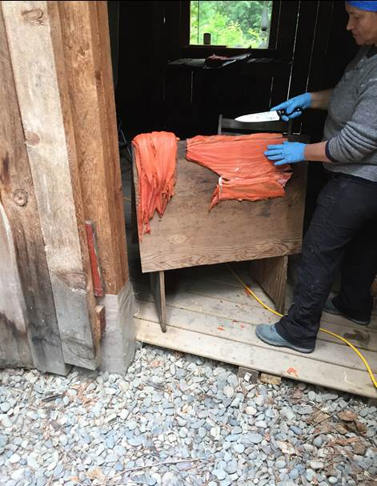

**Participants attending Nass Valley Wild Medicine Program workshop at the Nisga’a Museum**

**Spring 2018**

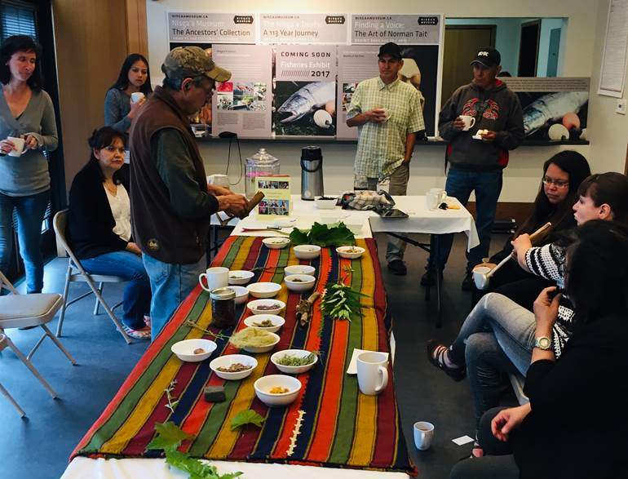

**Key Achievements:**

* 67.5 % completion was achieved for both cohorts 1 and 2.
* Approximately 70% are employed
* 12 clients who identified as homeless were successfully housed

PFAP clients benefitted from housing stability and the ability of the coaches/mentors in addressing other needs by offering guidance, supports, referrals, and encouragement to seeking further help. We were able to refer some of our clients to local counselling agencies such as Mourning Dawn, and Three Moons.

**Outstanding Client Success Stories:**

MB - has improved her lifestyle that lead her to have stable housing, two part-time positions resulting in a full-time job, and where she recently has been promoted to management.

Upon entering PFAP client MB had low self-esteem, was fleeing an abusive relationship, was homeless, and no job. Through the one-on-one coaching sessions/mentoring she gained more self-esteem and confidence in her personal abilities.

KH - single mother of two children was staying in the Ksan Women Shelter, she now has stable housing, increased self-esteem, and is waiting for interviews for potential jobs. She expressed tremendous gratitude for the PFAP coaching/mentoring that helped her make these positive changes.

KW - formerly chronically homeless man is now in post-secondary school and his goal is to become a social worker. He expressed wanting to change to be a positive role model for his adult children. He shared that he is at peace with his traumatic life at residential school. He is grateful for the PFAP program and all Kermode staff. He said that it was the PFAP program, the Kermode staff and his connection to other people in the community that helped him heal and learn to love himself and to be able to say I love you to others and mean it.

**Shared Knowledge and Increased Engagement:**

During the fiscal year 2017 - 2018, PFAP introduced the participants in the First Nations cultures in the surrounding areas of Terrace by providing opportunities to connect to the land, their language and culture to improve them self-identify, and become more involved in their communities and cultures.

**Participants attending Outdoor winter camp in Tahltan Territory about 6 hours north of Terrace, March 2018**

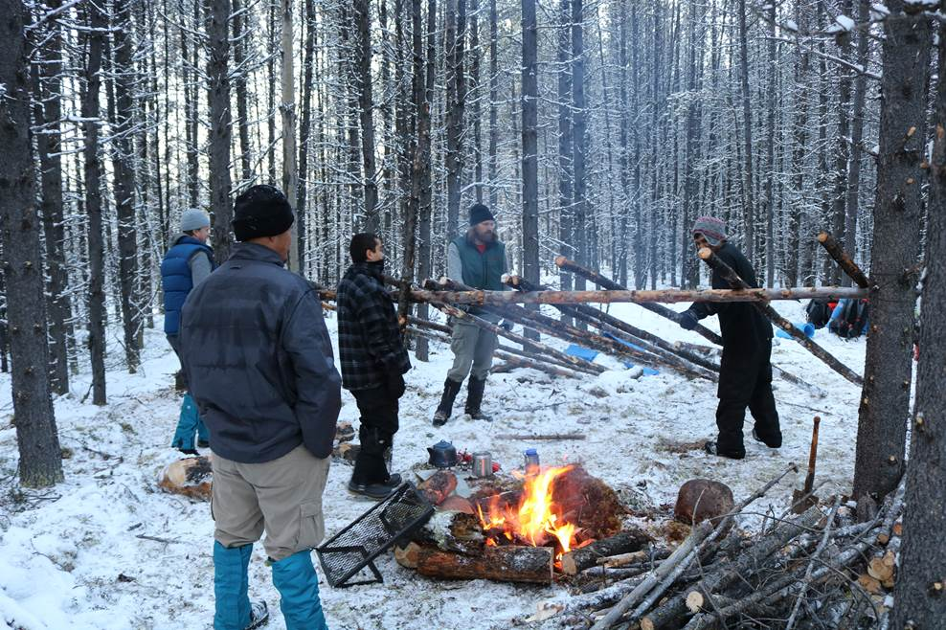

PFAP also provided opportunities for participants through work experience and job placements resulting in the participants gaining mentor relationships within the community and contributing to the clients identifying, recognizing, and appreciating their own personal skills.

This report will be shared with the city of Terrace and sister agencies. The successes of the graduates and their continuing challenges will assist in helping to close the gaps in services in our community.

**Managing Challenges:**

The numerous and sometimes constantly changing individual barriers/challenges of the participants demanded PFAP team’s flexible, innovative, creative ideas and responses to fully engage and motivate clients in this program including the team’s use of incentives such as gift cards and gas cards. The continuous participation of the clients was a challenge. We would organize activities and some time at the last-minute participants would not show. We also realized the reality of living day to day with multi-addiction and we had to accordingly plan other activities on the spur of the moment.

Extending the program and making amendments to the activities during cohort 2, greatly contributed to the successes of clients participating in the program and completing the program with housing/employment and education plans. They were able to experience and reconnect to the land, language and culture, along with the community. PFAP had a new clients in June 2018 when the program was extended. The additional June clients were already accessing other Kermode services and through word of mouth became interested in participating in the PFAP program.

Reaching out to those who had personal challenges making it difficult for them to complete the program contributed to finding out their challenges and coaching/mentoring them to utilize other community service providers such as counsellors to get back on the healthy lifestyle that they had experienced. Through encouragement, incentives and snack bags, PFAP staff were able to keep in touch with those who sometimes lost their strength to continue a healthy lifestyle.

Our community does not offer in-house treatment so clients needs to wait for a treatment bed which is a minimum of six (6) hours away from our community.

**Lessons Learned:**

* One to one coaching is effective
* Collaboration with other agencies is crucial
* Cash incentives are important but sometimes clients with addictions can use their incentives to support their habits
* Never giving up on people
* Cultural programs assist with self-esteem
* Stabilizing people is a process and takes a long time
* Advocacy is important
* Daily and weekly contact is important
* Communication with collateral agencies is a must
* Continuity with clients goes along way to establish trust
* Having a good network with the landlords goes a long way with finding housing

**Recommendations:**

1. Once contact has been made between job coaches/mentors and their clients, they should ensure that when the clients are being referred to other service providers within Kermode Friendship Society and outside of KFS, they should be seen by a minimum of two service providers of a service that the client has agreed to see. As we noted in the one client TA’s write-up (see appendices 2, Client write-ups cohort 2), this client has been seen by one outside service provider for the past 2 years and when there was family trauma in his life and that became too hard for him to handle, he reverted to alcohol.

1. We would offer shorter activities that could be delivered in one day to clients who start the program. We then would gradually increase the length of the activities based on how quickly clients would progress on becoming stabilized.
2. The clients already have various barriers and many challenges, so the incentives should be part of the program to help and motivate the clients to have their one-on-one coaching/mentoring sessions and to participate in the PFAP activities.
3. There should be at least two drug and alcohol counsellors on site so that clients can see them sooner. When clients build trust with their one-on-one coaches/mentors, they are more willing to see the referred service provider that their job coach recommends. They seem to be more willing to see referrals more easily after a session and when a drug and alcohol counsellor is more readily available after a session; additionally, the wrap around service would better serve the client in a timely manner. After a coaching/mentoring session the clients tend to be more motivated and receptive of further guidance.
4. Buy in with other agencies such as community mental health is critical.

**CONCLUSION**

The KFS executive expertise, guidance and support for the PFAP team was instrumental in PFAP’s clients’ successes and the PFAP teams continued support for the clients who had what at times seemed like insurmountable challenges. The PFAP team’s ability to build rapport with the clients and gain their trust required constantly adapting and responding to the clients almost at a moment’s notice

All the activities that were planned through the year were geared towards the clients experiencing positive changes by connecting to the land, culture, and language to experience positive changes and self-identification. Through the different activities they were able to positively view their own personal skills, which in turn helped them gain self-identity, self-esteem and confidence. Through this new insight and coaching/mentoring they were more motivated to want to make positive changes resulting in healthier lifestyles contributing to securing stable housing, becoming employable, getting full-time employment, getting education and getting involved in the community, etc.

Through collaborating with other service providers in the community of Terrace, Kermode has made an impression on many people with barriers who want to make changes. The PFAP not only successfully strengthened the KFS relationships in the community such as City of Terrace, Ksan Women’s Shelter, and TDCSS to help reduce the homelessness, it also demonstrated that PFAP benefitted the clients and service system in Terrace through the collaborative initiatives and consults that were formed with the service providers in the community of Terrace.

**Appendix A**

**Comparison of Cohort 1 and 2**

|  |  |  |  |
| --- | --- | --- | --- |
| **Categories** | **Cohort 1**  **Fall 2017** | **Cohort 2**  **Spring/summer 2018** |  |
| # of Participants | 20 | 20 | 40 |
| First Nations | 17 | 17 | 34 |
| # of males | 17 | 15 | 32 |
| Age range | 20-62 | 20-62 |  |
| # of females | 3 | 5 | 8 |
| Age range | 30-50 | 19-40 |  |
|  |  |  |  |
| # of participants who identified as homeless and who were housed | 6 | 6 | 12 |
| # who registered in post Secondary | 2 | 5 | 7 |
| # place in employment | 18 | 11 | 29 |
| # connected to the land | 6 | 8 | 14 |
| # who received legal advocacy | 4 | 1 | 5 |
| # attended the outdoor winter language and cultural camp (only offered in the fall of 2017) | 4 | 4 | 8 |
| Other cultural activities (drum making/ medicine picking) | 4 | 5 | 9 |
| **Total # of successful completions** | 13 | 15 | 28 |

Analysis:

* Total number of participants 40
* 85% were males
* 73% secured employment
* In total 12 people identified as homeless and all 12 were successfully housed

**Appendix B – Write-ups of Clients[3] mentioned in Final Report**

Participant: Marie

Marie is a single lady, from the Nisga’a Nation and now resides in Thornhill BC. When Marie came to the program, she was homeless and fleeing an abusive relationship.

Through one-on-one coaching/mentoring sessions, referral to other service providers within Kermode and outside of Kermode, Marie gained self-esteem, confidence, and connection to her community. Through gaining her trust, the PFAP team were able to help Marie overcome her barriers, of being homeless, having no job, alcoholism, low self-esteem through guiding her to the different service providers.

While participating in PFAP, Marie was great to work with, very committed to housing search, job search, updating resumes, and follow up calls with employers and she was able to connect with other employment agencies. She is working on acquiring a driver’s license.

The services she received were one-on-one coaching/mentoring, PFAP activities such as the job search, resume building, learning how to do follow-up calls with employers, connect with other employment agencies, referrals to other support services that helped her significantly, client support such as work gear and bus passes.

She was able to secure a safe place to live, a job placement (since April 2018), and maintain sobriety. She had two part-time positions for employment that she expected to be long-term. She was offered a promotion at the Pita Pit and now works full-time there.

Marie graduated from PFAP. Marie works full-time at Pita Pit after she received a promotion. We are very proud of her for overcoming her barriers to become self-sustaining, abstain from alcohol, and full-time employed.

Participant: Kenny

Kenny is from the Nisga’a Nation. He is 62 years old. He has lived in Terrace for more than 20 years. He has overcome his barriers of addiction and has been successfully sober since November 2009. He has enrolled in Coast Mountain College for The Social Service Worker Diploma Program. He is entering his second year of the program this September 2018.

Through his one-on-one coaching/mentoring sessions, and participating in the PFAP activities, Kenny has learned to be self-sustaining, has gained self-esteem, self-identity, and he learned to forgive, to love unconditionally. He now holds his head up when he talks about his history of residential school and his healing journey, and that what happened there was not his fault, and what happened to him, he does not and should not be ashamed. Through his positive life changes of going to college to become a social service worker, he met other people who helped him on his journey of healing.

The services Kenny received were Housing, one-on-one coaching/mentorship sessions, bus passes, gift cards for food, educational support – secured his seat by paying for it and cleared his student financial debt that would have prevented him from continuing his education this September 2018.

He was evicted (June – July 2018) from his apartment due to being behind on rent. He was homeless for a while during that time and has continued his studies. He returned to school and has been referred to TDCSS and Turning points for financial assistance. He has secured stable housing. He is a great example of determination and personnel growth. He will be a definite asset to his chosen line of work.

He is very grateful to the Kermode Friendship Society, the PFAP staff, and another family program that was offered a couple of years ago through Kermode. He hopes to see more programs like PFAP run through Kermode because it absolutely helped him on his healing journey. He was proud to graduate from the PFAP program and wanted to be a good role model for his adult children, who will be entering college in January 2019.

Participant: Kerry

Kerry is a 35-year-old single mother of two boys, 3 and 6 years old. She is part of the Gitxsan Nation. She has lived in the Terrace for 8 years with her common law husband with which she is now separated. She was unable to maintain the apartment financially after being left overdue on rent. Multiple RCMP calls about her spouse eventually led to MCFD getting involved as concerned social services in the community on behalf of the children. After unsuccessfully acquiring a place of her own and losing the couches they were staying at, she became homeless and was forced to stay at the woman’s shelter with her children. She was then referred to Ksan woman’s shelter link workers/ TDCSS Anti – Poverty and Turning Points. While working with the Kermode PFAP and Housing team she was successfully housed in a new 2-bedroom apartment. Further supports were applications to BC Housing Registry for the Rental Assistance Program.

Through her one-on-one coaching/mentoring sessions and various activities, Kerry gained life skills to become independent and self-sustaining.

Through the visit to the Nisga’a Museum, we seen Kerry transition, and connect to the land, language and culture. She was very quiet when we first went on our trip. After having lunch at the Vetter Falls Lodge, she opened, talked more about her dreams, and that she loved it there in the Nass Valley that she did not want to leave there. A connection was made, and she made a lot of positive changes for herself. She kept dropping in at Kermode PFAP department occasionally to let us know what types of things she conquered that day. She had gained self-esteem, self-identity, and dignity in who she is.

After she participated in the T’Eliksit Language and Culture camp Kerry gained more connection to her language and culture from her experience there, participating in catching the fish, cleaning, and processing them. She learned of how her cultural system worked through the educational traditional information that the Gitxsan knowledge leaders and Elders shared at that camp (they were brought in as guest speakers). She learned of the discipline, morals, and values that were displayed and offered to them. Some of these characteristics were not part of her characteristics shown in prior interactions, and we believe that this has contributed to her wellness and positive changes.

Her participation in the drum making work shop strengthened her connection to her land, language and culture too.

Through these PFAP activities, supported guidance to other service providers within Kermode and outside of Kermode, and through one-on-one coaching/mentoring that Kerry participated in has helped her gained self-identity, self-esteem, confidence, and dignity. We see that she is eager to do more for herself and her young family. She understands how important she is, through connections to her land, language and culture, and to her community.

She is currently accepted into the CCP local college and has enrolled her youngest into Kermode head start school.

Kerry’s family Housing is stable and secure. She is working on getting her learners license and employment. We know that she will succeed in her future endeavors. We let her know that although the PFAP program is finished, she is welcomed into the Northern Corridor Program, and that the she can continue getting support to look for employment, supports of guidance to other service providers within Kermode and outside of Kermode. From gaining her trust, she has learned that it is ok to reach out to seek guidance to succeed in employment and education, and that there are a lot of opportunities out there. We are proud of her and for all her hard work in PFAP.

Participant: Terrance

Terrance is from Nisga’a Nation. He entered our services needing housing support for being chronically homeless and employment resources after successfully staying sober for the past two years. He was referred to Turning Points and TDCSS for housing support financially and was successful in attaining stable housing. The PFAP has provided supports such as online courses ex. (CSTS, WHMIS and TDG). He participated in the two PFAP activities, a visit the Nisga’a Museum and attend a medicinal herb workshop, and the medicine picking workshop. Terrance successfully connected to the land, language and culture, in which helped him connect with his identity.

At first Terrance missed attending the PFAP program and its one-on-one services. He did drop by our office area to get other supports such as the snack bags and to look for employment. He was trying to find work on his own.

Through our reaching out to him and letting him know of the remaining PFAP activities, such as the visit to the Nisga’a Museum in Greenville, the T’Eliksit Language and Culture camp, Medicine Workshop, Medicine picking workshop, the Drum Making workshop, our work experience job placements. We explained to him that we strongly believed these activities would help him overcome his barriers to become successful self-sustaining and employable.

Terrance was really interested in the work experience job placement because he knew that this would help him find full-time employment in his field of work he liked. Through his one-on-one coaching/mentoring sessions Terrance gained back his self-esteem, confidence and his dignity. He understood that his positive changes that he has made for himself, getting counselling for his alcoholism, stopping drinking and entering the PFAP program were huge successes that he has accomplished for himself. After some one-on-one coaching sessions, he gained confidence to ask for help to get a work experience job placement at Progressive Ventures where he worked three years prior to entering the PFAP program. He explained that he was fired from that company due to his unstable lifestyle and alcoholism. He said that after the former boss of that company fired him, he told him never to apply there again. We let him know that we were confident that the company would consider taking him on through work experience job placement because they know of Kermode Friendship Society’s programs that help people heal and make positive life changes, and that they did participate in a similar activity, called Job Shadowing. We let him know that if he did get that work experience job placement there, it would be up to him to show and win back that company’s trust that he has grown more responsible and has stronger work ethics.

Through PFAP advocating for him to work at Progressive Ventures, to be considered for the work experience job placement, Terrance was hired full-time instead. He did not go through the work experience job placement.

Terrance was later laid off due to shortage of work and was told that when work picked up, he would be called back to work for them. At that time, he had traumatic news about his mom, and that caused him to fall back into his alcoholism. From our PFAP teams’ ability to gain his trust, we kept in touch and urged him to see his drug and alcohol counsellor, that it was not too late to make changes, and that there was still time to turn his life around and be ready to go back to work with Progressive Ventures when they call him. Terrance let us know that he trusted one drug and alcohol counsellor, and that person was away on vacation. So, there was no one he trusted to see at that time. We told him that he can reach out to us, and that he did not have to be alone in that hard time in his life. We reached out to him every other day to coach him, to let him know that we could see him and talk.

Once the alcohol and drug counselor returned from vacation, he seen Terrance right away. Terrance bounced right back on track with abstaining from alcohol and he participated in the medicine workshop and the medicine picking workshop. Those workshops helped him a lot to reconnect to his self-identity and to work on positive things. Terrance really believed that those two workshops would help him, he participated while he was still feeling ill from his alcoholism and from being recently discharged from the hospital at that time. He even told us that he could feel the difference in himself from the medicine picking workshop. After the medicine picking workshop,

Terrance let us know that he was called back to work with Progressive Ventures and he is now full-time employed working at a camp with Progressive Venture. He is still seeking counselling support for his alcohol addiction and Kermode will support him in his journey. Terrance was very grateful that our PFAP team was there to help him through his rough part of his life. We are proud of his determination to do better for himself, to show his adult daughter that he has the will to overcome his alcoholism and maintain a full-time job.

|  |
| --- |
| **Funded by the Government of Canada's** Homelessness Partnering Strategy**.** |

1. This final report prepared by Angela Percival, Coordinator and Cal Albright ED, KFS
2. For the purposes of this report the definition of homelessness is an individual or family who has an annual income of below 30% of median family income for the area and does not have sufficient resources or support networks immediately available to prevent them from moving to an emergency shelter… ( see US Development of Housing and Urban Development.
3. To respect client confidentiality first names have been used.