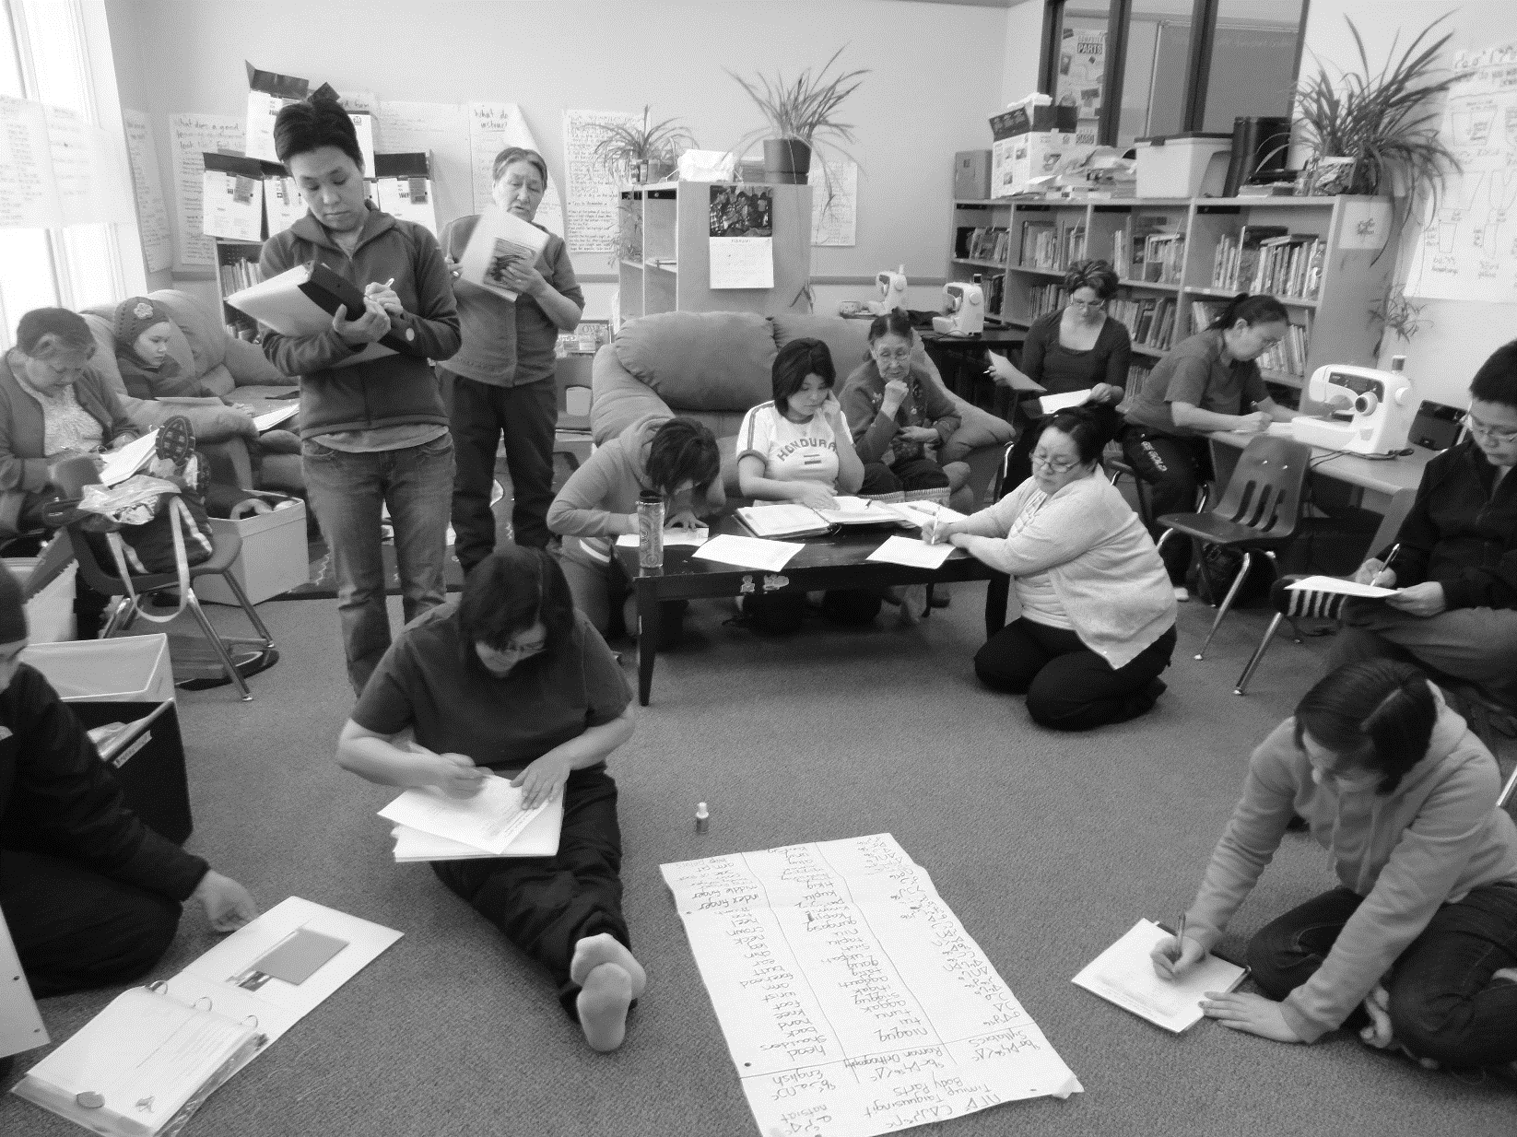

Promising Practices Self-Assessment Tool

First Nations, Inuit and Métis Essential  Skills Inventory Project | Canadian Career Development Foundation

About the Self-Assessment Tool

Background
The Self-Assessment Tool uses 12 Markers of Promising Practice identified by the First Nations, Inuit and Métis Essential Skills Inventory Project (FIMESIP). The 12 Markers were defined through extensive research and consultation that included a literature review, an analysis of over 100 Essential Skills initiatives, in-situ research on 10 case studies, and consultation with Indigenous and education leaders on the Steering Committee, Working Group and Community of Practice. To learn more about the research methods and process, visit fimesip.ca.

Purpose of the Tool
This self-assessment tool can be used by anyone involved with the development or delivery of an Essential Skills (ES) initiative for Indigenous people. It assists you in measuring the presence of the 12 Markers within your Essential Skills initiative. It can help you identify strengths and areas for improvement. The information gathered through the assessment can be used to promote your promising practices, refine and strengthen your existing ES projects, and guide the development of future ES projects.
There is a User Guide (available at fimesip.ca/program-self-assessment/) to support you in working through the tool that follows. The Promising Practices Self-Assessment is underpinned by an evidence-based methodology. For each indicator that you score as either “underway” or “in place” there is a space underneath the applicable rating to note down evidence or a description of activities that validates your rating of the indicator. This process is fully described in the User Guide, and will help you provide evidence of your assessment that you can use to promote the efficacy of your initiative to stakeholders.

Promising Practices Self-Assessment Tool

Marker 1: First Nations, Inuit, and Métis control and ownership of their own education and training initiatives
Indigenous ownership over education, training, and resource development has proven vital to Indigenous participants’ increased educational attainment, and to the overall effectiveness of employment training projects targeting Indigenous populations.
Indicators of promising practice | Rating
 | Not started  0 | Under way  1 | In place  2 | N/A
ES training needs are identified by an Indigenous organization/community.
Indigenous organizations or communities lead the development, design, management, implementation, and instruction of the initiative.
Indigenous organizations, community members, and/or Elders are consulted with and involved in all aspects of the initiative (e.g., development, design, and delivery).
Total Score

Evidence of the Assessment: (Examples of evidence that that will support your assessment. E.g. Photos of consultation process, a list of organizations involved in the design of the initiative, a report on a community asset/needs mapping process)

Marker 2: Partnerships
Mutually beneficial and collaborative relationships with key stakeholders groups at all stages of your initiative facilitate knowledge-sharing, successful integration of the Essential Skills in the workplace, and best practices in program design, planning, and delivery.
Indicators of promising practice | Rating
 | Not started  0 | Underway  1 | In place  2 | N/A
The initiative’s partnerships include a diverse range of key stakeholder groups who are actively involved throughout its development and/or delivery (i.e., other Indigenous service providers, educational institutes, employers, community groups/ organizations, governments, funders).
The partners have regular opportunities to provide feedback and have their input integrated into the elements of the project.
The Project Advisory/Steering Committees include partners and key stakeholder groups
(i.e., community members, employers, educational institutions, community organizations).
Total Score

Evidence of the Assessment: (Examples of evidence that will support your assessment. E.g. A list of partners/stakeholders involved in the project, a document on the process of their involvement)

Marker 3: Working with and in the Community
Working directly with community members ensures community buy-in, strengthens participant-community connections and contributes to community capacity building.
Indicators of promising practice | Rating
 | Not started  0 | Underway  1 | In place  2 | N/A
Staff work with the community to identify their needs (e.g., training, employment, cultural, etc.), and tailor the project to meet those needs.
Community members are involved in the development, recruitment and delivery of the project.
The delivery model is responsive to the local community environment (e.g., rural, remote, urban, band offices, reserve community).
The initiative is promoted using methods best suited to the community and its members (e.g., Facebook posts, community radio announcements, flyers, open houses, community meals).
The project is visible in the community (e.g., the initiative is delivered in the community, takes part in community events, plans community events, uses community facilities for program activities).
Community and family members are encouraged to visit (e.g., elders in residence, family and community days, open door policy, community coffee rooms), and are invited to coordinate, attend, and participate in program graduation or completion ceremonies.
Program information is provided to participants’ families to help them understand the program and the expectations for their family member.
Staff work to build capacity within the community to support the sustainability of the initiative.
Resources and professional development opportunities are shared with other community organizations.
The initiative links participants to their local community resources, services, and supports.
Total Score

Evidence of the Assessment: (Examples of evidence that will support your assessment. E.g. Photos of family days, a resource list of community resources, a project plan for involving the community in the project, an evaluation report on the impact of the community’s involvement on the project)

Marker 4: Learner-Centered Approach
Participants are at the centre of the initiative. Their needs drive its design, development and delivery.
Indicators of promising practice | Rating
 | Not started  0 | Underway  1 | In place  2 | N/A
A key objective of the initiative is to build hope, self-esteem, and self-awareness among participants.
Participants’ strengths, needs, experience, and aspirations guide the learning.
Program delivery structure (e.g., start times, location, and schedule) and curriculum are flexible and tailored to participants’ individual learning needs and lived realities.
In-take procedures are informal and inclusive; they focus on establishing rapport with participants and identifying participants’ interests and goals.
Assessment processes are used to help participants identify their goals, skills, readiness levels, skill gaps, and to establish an action plan.
Participation in the initiative is voluntary.
Participants are aware of and understand all the elements, requirements, and expectations of the project.
Participants are provided with a safe environment where all are accepted, learning is individually paced, risk-taking is supported, respect is paramount, and learners are encouraged to support each other.
Participant-staff ratios are set to ensure adequate support and participant engagement.
Staff build a working alliance with every participant to help learners reach their identified learning goals.
Learners and instructors develop co-assessment strategies that acknowledge learner progress and identify strategies to support development.
Your program builds a sense of community among participants.
You provide transitional supports and follow-up with participants after the completion of the program (e.g., transition from training to work or advanced training, and/or pathway exploration).
Total Score

Evidence of the Assessment: (Examples of evidence that will support your assessment. E.g. Examples of participants’ individualized learning plans, training manuals, participant testimonials, evaluation reports)

Marker 5: Holistic Approach to Essential Skills Program Delivery
Your programming recognizes each participant as a whole person, provides them with wrap-around and individualized supports, and addresses issues that may be barriers to their success.
Indicators of promising practice | Rating
 | Not started  0 | Underway  1 | In place  2 | N/A
The multiple needs of First Nations, Inuit, and Métis participants (e.g., physical, mental, emotional, social) are reflected in the initiative’s curriculum and/or supports available to participants.
Participants’ needs are assessed and supports are provided to address identified barriers to their success (e.g., counselling, child or Elder care, transportation, nutrition/meals, driver’s license, learning supplies, financial supports, housing, occupational equipment/tools).
Family members are prepared and supported if participants are required to be absent from their home community.
Curriculum targets a range of key skills that will support increased participant employability (e.g., Essential Skills, life skills, employability skills, career management skills, job search, academic upgrading, technical skills, industry-recognized licenses/certificates).
Participant attendance and retention are addressed through individualized incentives and support (e.g., attendance allowances, regular check-ins, individual sessions, phone calls).
There is on-going participant support after the completion of the program to help participants address barriers and move towards their career goals (e.g., career services, childcare, transportation, housing).
All participants, whether they complete the program or not, have an exit interview and leave with an action plan.
Total Score

Evidence of the Assessment: (Examples of evidence that will support your assessment. E.g., the initiative’s participant’s support plan, copy of the needs assessment, a list of participant supports, a copy of the curriculum)

Marker 6: Experienced and Knowledgeable Staff
Initiative’s staff are aware of, sensitive to, and capable of meeting the unique needs of First Nations, Inuit, and Métis learners.
Indicators of promising practice | Rating
 | Not started  0 | Underway  1 | In  place  2 | N/A
Staff are Indigenous and/or have experience and expertise working with Indigenous participants.
Staff have training and experience in the development and delivery of Adult Education, Essential Skills, Career Development and/or employment related training programs.
All staff are knowledgeable and respectful of First Nations, Inuit, and Métis culture. Competency training in First Nations, Inuit, and Métis cultural diversity is available/provided to project staff.
Staff have additional training or experience in first aid, mental health first aid, front line support work, and/or crisis intervention.
Staff are organized, skilled, creative, in tune with learners’ needs, and able to build rapport and motivate participants.
Staff and management work as a team and coordinate efforts to support participant success.
Industry skill instructors have recognized credentials and/or are certified in their field of instruction.
Staff are provided with on-going professional development.
Staff participate in regular, performance-based assessments of their work and have opportunities to build needed skills.
Total Score
Evidence of the Assessment: (Examples of evidence that will support your assessment. E.g. Staff credentials and bios, performance assessment reports, participant testimonials)

Marker 7: Principles of Adult and Indigenous Learning
Your initiative is inclusive of different learning styles, and uses a wide range of both Adult and Indigenous instructional and evaluative strategies and techniques.
Indicators of promising practice | Rating
 | Not started  0 | Underway  1 | In Place  2 | N/A
A wide range of instructional and assessment methods to support different learning styles are used.
Learning activities are experiential, hands-on, interactive, and have applications to real world and/or workplace tasks.
A balance between the theory, knowledge, and application of practical skills is made.
ES are integrated into course materials and are taught/demonstrated within the context of both workplace and traditional activities.
Participants learn through traditional methods of observation, imitation, and intergenerational learning (e.g., involvement of Elders).
Your initiative’s environment supports and promotes expected behaviours (e.g., participation, attendance, being on time.).
Your initiative develops and tests new methods to learn or assess ES, which incorporate current techniques, technologies, and participants’ learning needs or preferences (e.g.., computer applications, distance learning).
Participants have structured opportunities to reflect on and self-evaluate their goals, ES development, and accomplishments.
Participants are meaningfully involved in program planning, implementation, data collection, and evaluation.
Total Score
Evidence of the Assessment: (Examples of evidence that will support your assessment. E.g. Curriculum, photos of participants in experiential learning environments, testimonials of instructors and/or participants)

Marker 8: Culture, Language, and Traditions
Your initiative facilitates learning within an Indigenous context. It includes traditional teaching methods, activities, and resources.
Indicators of promising practice | Rating
 | Not started  0 | Underway  1 | In place  2 | N/A
Your initiative’s philosophy and approach is rooted in Indigenous culture, traditions, and values.
Elders are actively involved in the development and delivery of programming, are on Advisory Boards, attend training events, and teach or counsel.
Curriculum includes components that focus on Indigenous culture, tradition and language.
The initiative supports participants’ learning of their own local indigenous history, culture, tradition, and language.
Culturally based learning methods are used (i.e. talking circles, storytelling, art, music.).
Culturally appropriate and relevant materials/texts are developed and used.
Participants are able to use and access content and resources in their own language.
Total Score

Evidence of the Assessment: (Examples of evidence that will support your assessment. E.g. curriculum examples, texts in Indigenous languages, photos of Elders interacting with participants, Elder testimonials)

Marker 9: Employer Involvement and Direct Workplace Experience
The initiative has direct links with employers, providing participants with work experience opportunities and meeting employers’ needs for a skilled and diverse workforce.
Indicators of promising practice | Rating
 | Not started  0 | Underway  1 | In place  2 | N/A
The initiative provides work experience opportunities that allow participants to acquire job related experience, learn about workplace culture, and develop employability skills.
The initiative creates partnerships with employers (and their networks), which supports participants’ future work development opportunities.
Staff work directly with employers to coordinate participants’ transition from training to the workplace.
Employer partners are directly involved in the development and delivery of the project.
The initiative works directly with employer partners to identify the specific competencies needed to do the job being offered and customizes participant training to reflect the ES and competencies required to successfully get and keep that job.
Employers provide feedback to the project to ensure that training continues to meet the needs of the workplace and job roles.
There are workplace supports in place to help participants succeed in the completion of their training placement
(e.g., on-site monitoring, follow-up, work place mentorships, etc.).
Employers and their staff are oriented to the project and it goals in order to better support successful work placements.
Participants and employers have the opportunity to share feedback during the work placement so any issues preventing success may be addressed.
Indigenous awareness & workplace inclusion training is provided for employers.
Employers have culturally sensitive human resources personnel that can effectively assist participants experiencing inappropriate workplace behaviours.
Total Score

Evidence of the Assessment: (Examples of evidence that will support your assessment. E.g. Employer and participant survey reports, copies of the employer awareness training curriculum, participant employment performance reviews)

Marker 10: On-going Communications
Your communication strategy ensures regular, ongoing, and clear communication between all of your initiative’s stakeholders.
Indicators of promising practice | Rating
 | Not started  0 | Underway  1 | In place  2 | N/A
A well-defined communication strategy for program partners, funders, and stakeholders is developed and implemented.
You have regular on-going communication between staff, participants, employers and stakeholder groups.
Program progress and final reports are shared with and accessible to partners, stakeholder groups and the community.
Total Score

Evidence of the Assessment: (Examples of evidence that will support your assessment. E.g. Copy of the communications strategy, participant survey reports, stake holders distribution list)

Marker 11: Established Evaluation Criteria and Methods
Evaluation is built-in from the inception of the initiative and is systematically continued throughout its delivery.
Indicators of promising practice | Rating
 | Not started  0 | Underway  1 | In place  2 | N/A
An evaluation plan is built into the initiative’s design, and informs project development, delivery, and subsequent changes to the initiative throughout.
Evaluation methods are guided by clearly defined, measurable goals that are linked to participant and community needs.

Monitoring and reporting systems are in place to follow participant progress and impact during and after the project.
Quantitative and qualitative data is collected (e.g. surveys, partner feedback, participant feedback, student success stories, etc.) to measure outcomes, project impact, and demonstrated success.
Evaluation reports are accessible to the public and readily shared with partners and stakeholder groups.
Total Score

Evidence of the Assessment: (Examples of evidence that will support your assessment. E.g. evaluation reports, evaluation methodology and plan, participant outcome data)

Marker 12: Promotes the Business Case
The initiative clearly demonstrates to key stakeholders how involvement in the project benefits them.
Indicators of promising practice | Rating
 | Not started  0 | Underway  1 | In Place  2 | N/A
The initiative measures and reports on use of funds and return on investments.
The initiative evaluates and reports on the outcomes, impact and benefits to stakeholder groups.
Successful participant outcomes are connected to successful employer outcomes (e.g., improved safety on-site, less training needed, enhanced productivity, etc.).
The initiative demonstrates to employers the potential benefits of their involvement.
Total Score

Evidence of the Assessment: (Examples of evidence that will support your assessment. E.g. A return on investment report, reports on use of funds, outcome reports, employer testimonials/surveys)

Scoring key:

Markers of Promising Practice | Gap/  Challenge | Underway | In place
- First Nations, Inuit, and Métis control and ownership of their own education and training initiatives | < 3 | 3-4 | 4-6
- Partnerships | < 3 | 3-4 | 4-6
- Working with and in the Community | < 10 | 10-15 | 15-20
- Learner-Centered Approach | < 13 | 13-20 | 20-26
- Holistic Approach to ES Program Delivery | < 7 | 7-11 | 11-14
- Experienced and Knowledgeable Staff | < 9 | 9-14 | 14-18
- Principles of Adult and Indigenous Learning | < 9 | 9-14 | 14-18
- Culture, Language, and Traditions | < 7 | 7-11 | 11-14
- Employer Involvement and Direct Workplace Experience | <11 | 11-16 | 16-22
- On-going Communications | < 3 | 3-4 | 4-6
- Established Evaluation Criteria and Methods | < 5 | 5-8 | 8-10
- Promotes the Business Case | < 4 | 4-6 | 6-8

Essential Skills (ES) initiatives are considered to be any of the following interventions to support the development of Essential Skills: training or skill development programs, tools or resources to support Essential Skill development, Essential Skill assessments, development of learning plans, and awareness building activities.

